**WEBSITE TEST PLAN**

**BLACK BOX TESTING**

Test 1: Opens on multiple browsers

The website successfully opens in multiple browsers such as chrome, Internet Explorer and Microsoft edge.

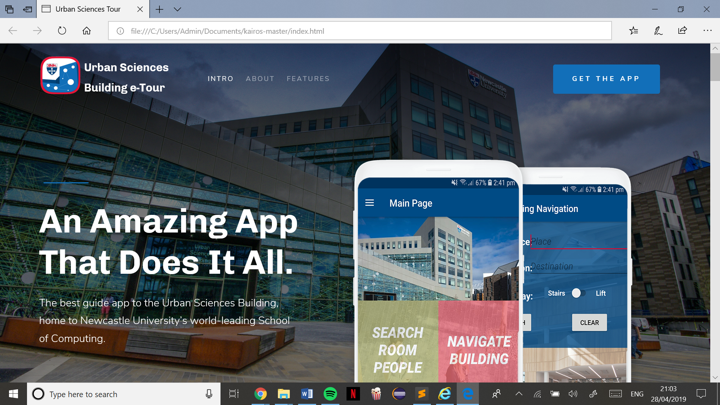 Microsoft Edge

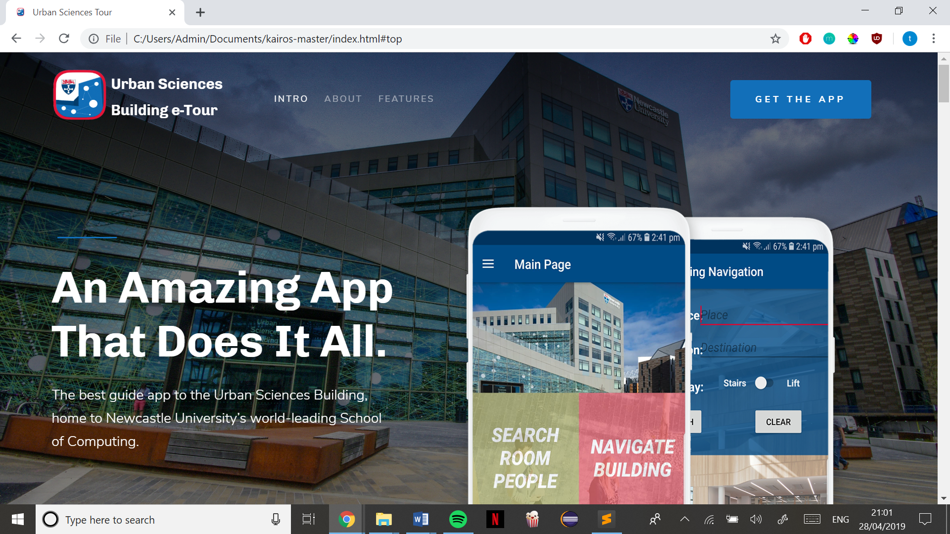 Chrome

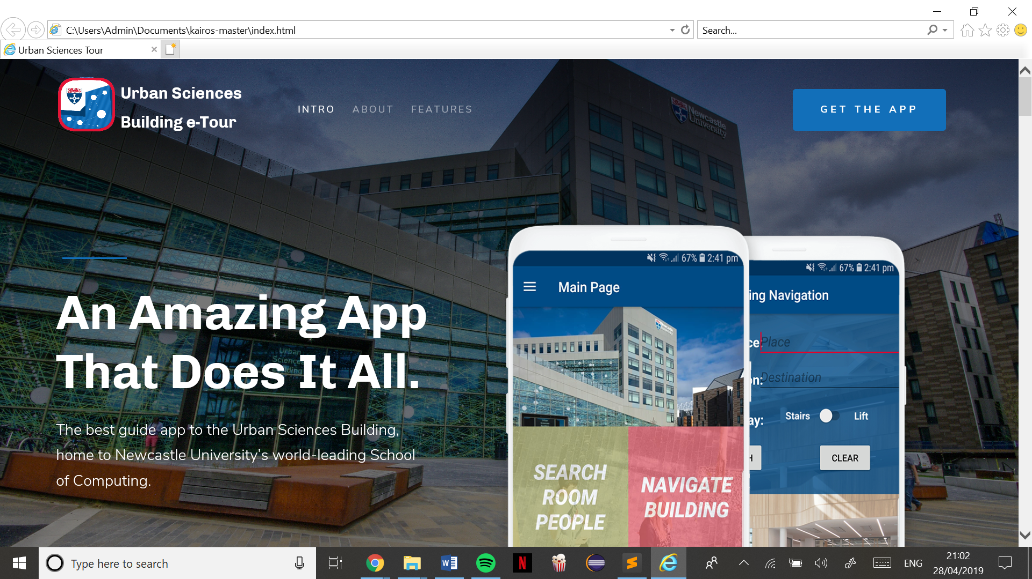 Internet Explorer

Test 2: Use all the navigation and features of the website

Clicking the links in the navigation bar jumps to the right part of the website and clicking ‘get the app’ takes me to the download section of the page, and clicking the logo ‘urban sciences’ takes me back to the homepage as expected.

Clicking the return to top arrow returns me to the top of the page(homepage) no matter which part of the website I am on.

Clicking the walk through video pops up the correct tour video from YouTube.

The email subscription box correctly displays a ‘we have sent a confirmation email’ once an email is submitted

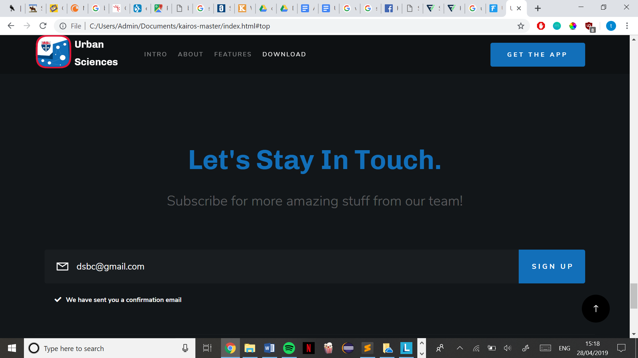

Test 3: Stress test the Javascript and make sure all functions run as expected

I clicked each featured several times in hopes of breaking it but it performed its task correctly, for example, I scrolled all the way down, and kept clicking the ‘back to top arrow’ it buffered a bit each time I clicked as it slowed down moving up the page but no amount of clicks effected its purpose. All Javascript ran smoothly and without a problem.

Test 4: Resizing browser

Website runs successfully when resized, displays correctly on any resized size.

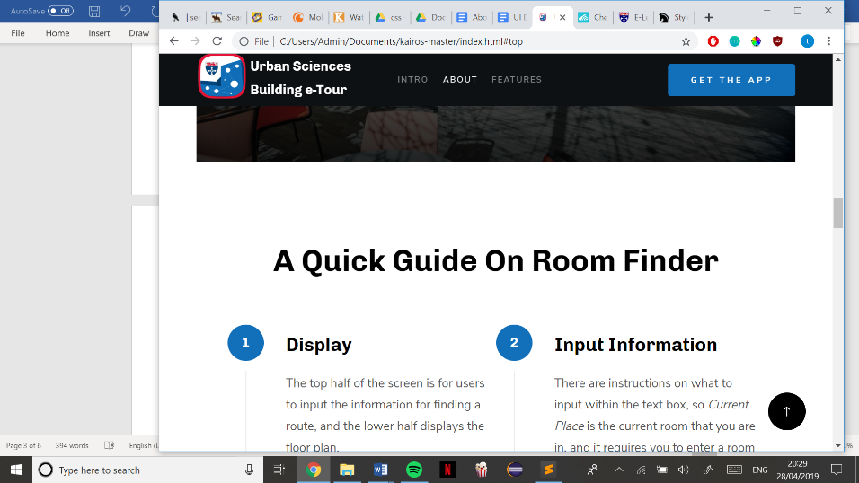

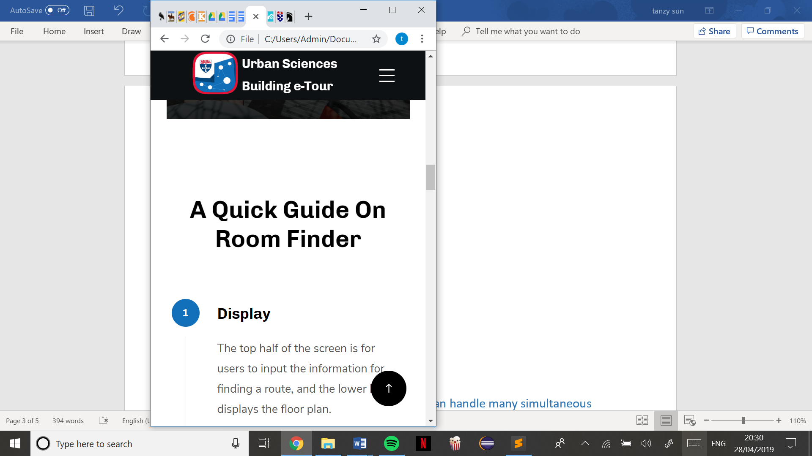 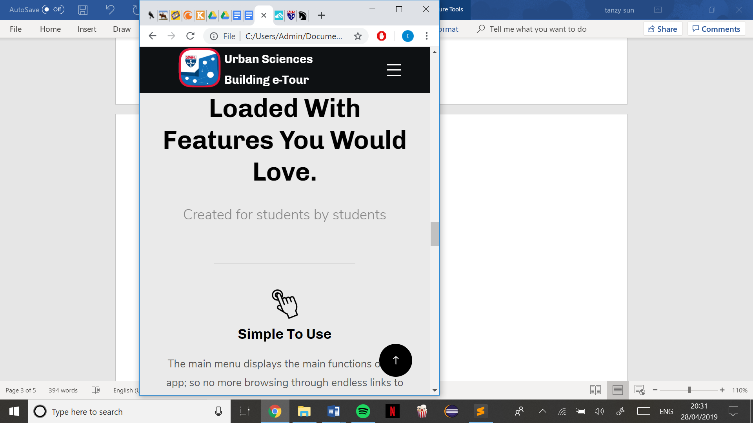 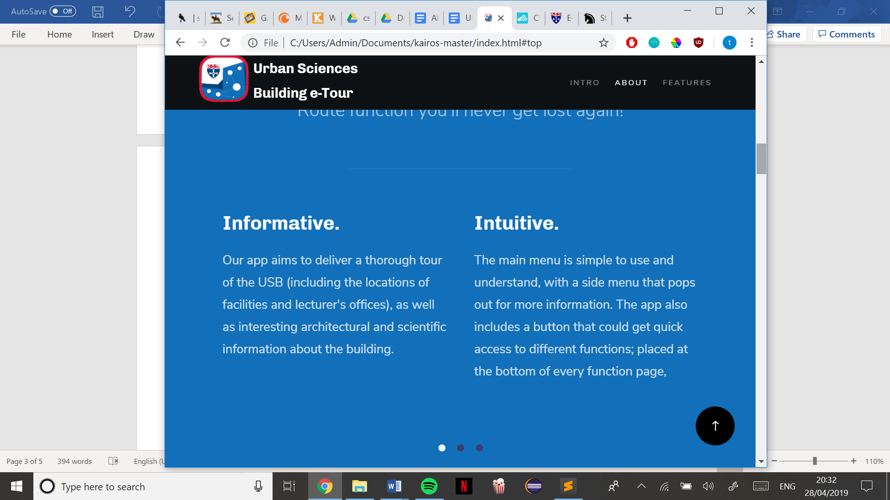

Test 5: Open on different devices

Website successfully opens and loads on a mobile device.

Test 6: Load test the website to make sure it can handle many simultaneous user requests

To test this, I had many tabs of the website open in Chrome, and all functions performed smoothly as usual. Several members of the team also had the website open on their own devices and tested each feature, but the website remained unaffected and performed smoothly as usual

Test 7: Testing all links

There aren’t any external links apart from the YouTube video, which loads and displays correctly, all internal links such as from the navigation bar works correctly.

**WHITE BOX TESTING**

Test 1: HTML code meets mark-up validation

Website passed HTML checks successfully, there’s no errors or warnings.

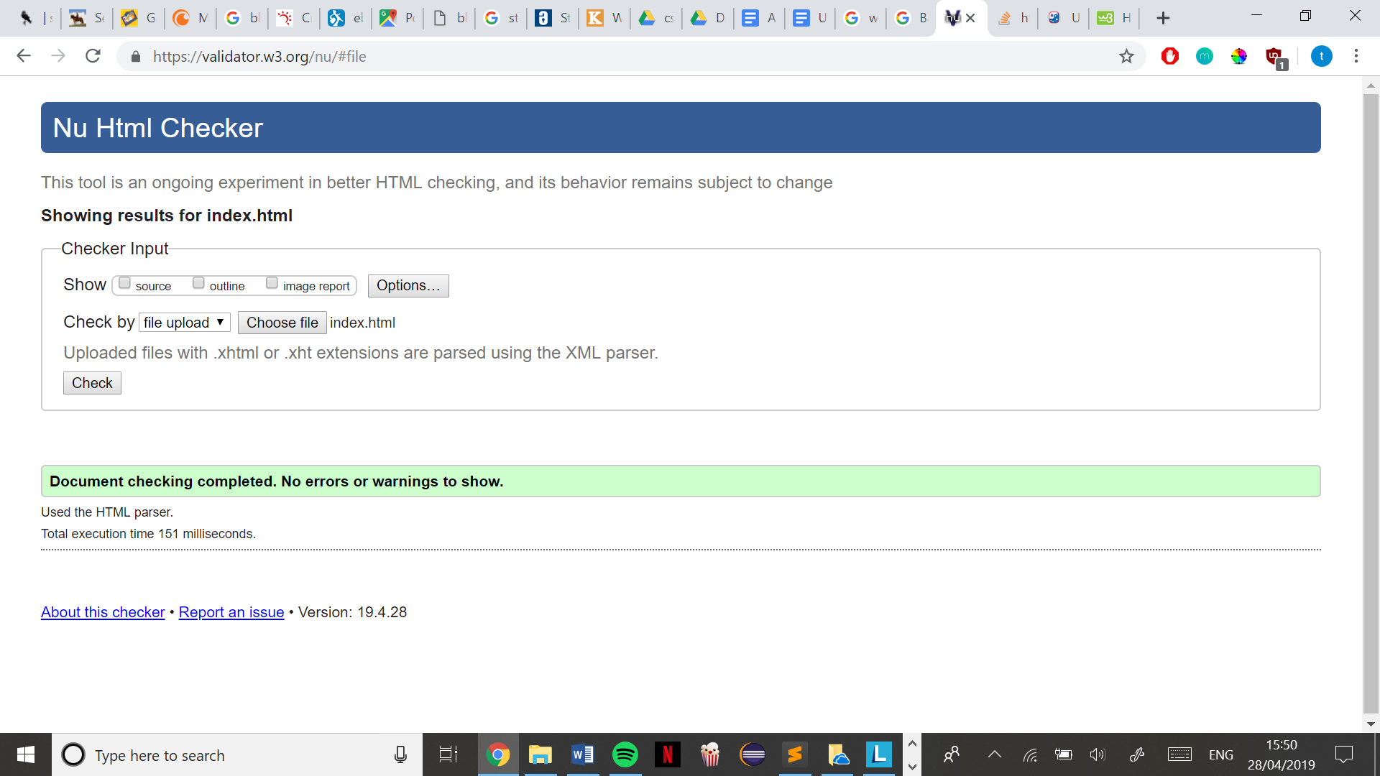

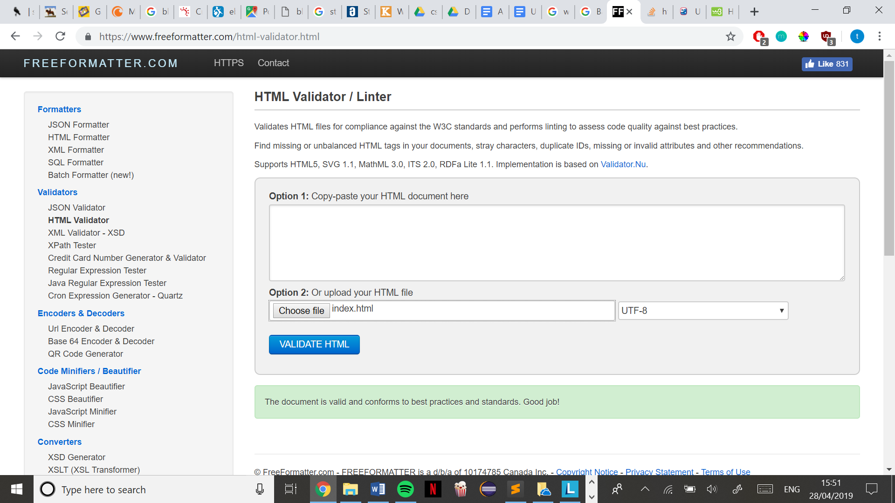

Test 2: CSS code meets mark-up validation

Base.css successfully passed, no errors found. 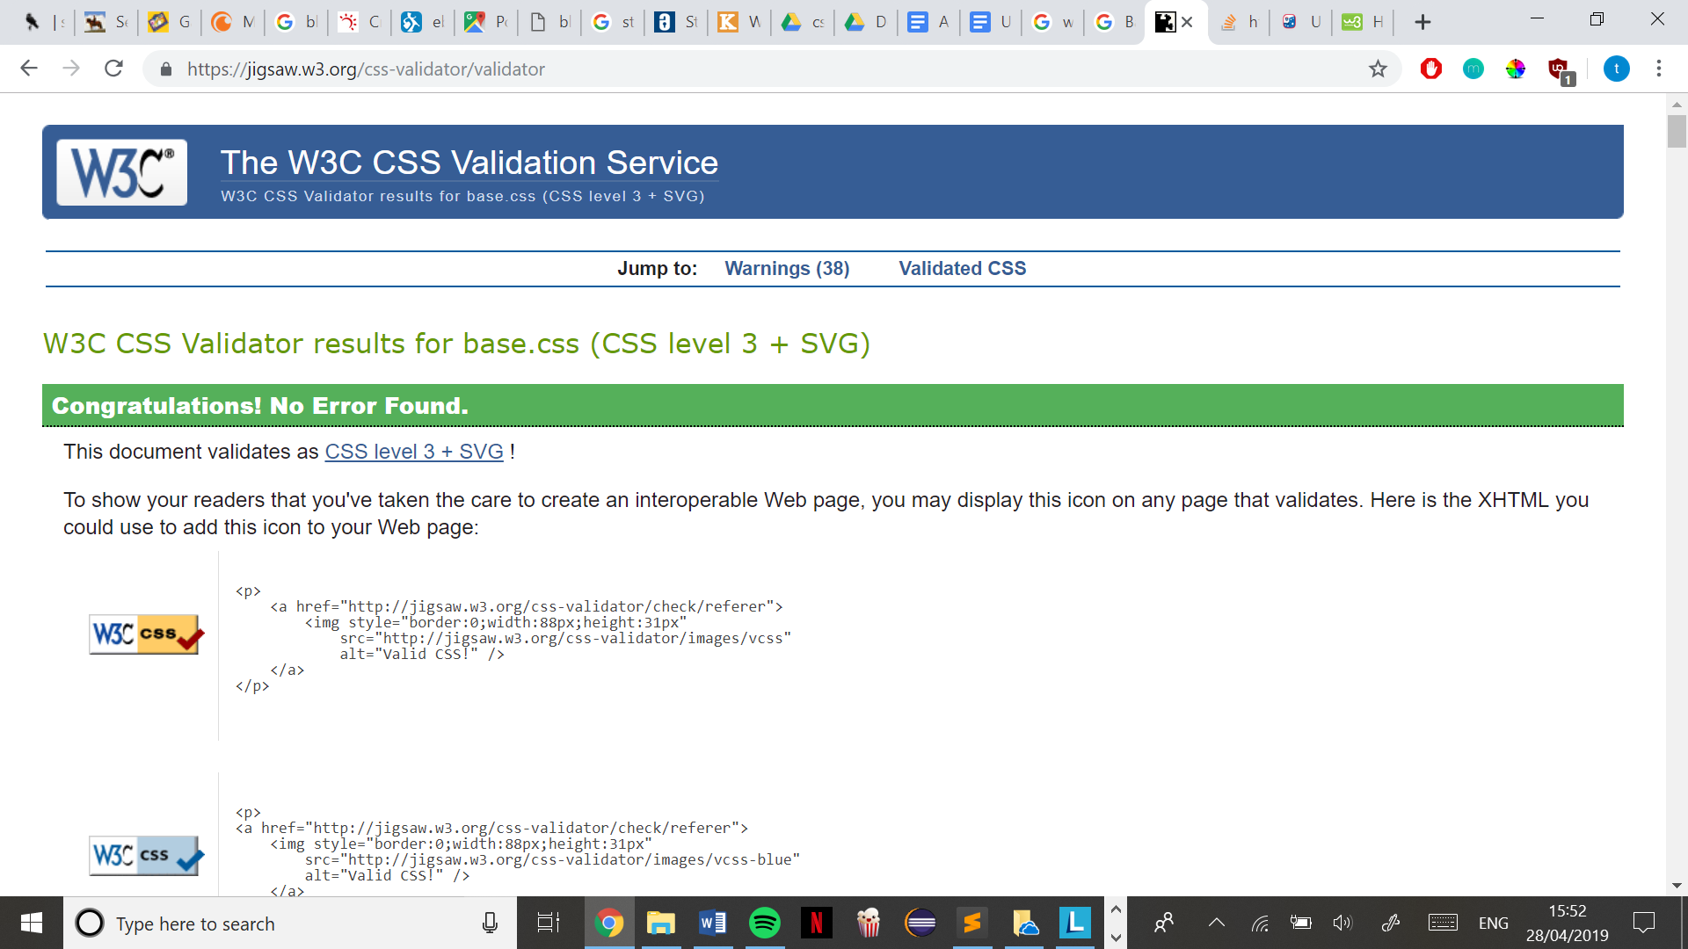

Main.css successfully passed, no errors found.

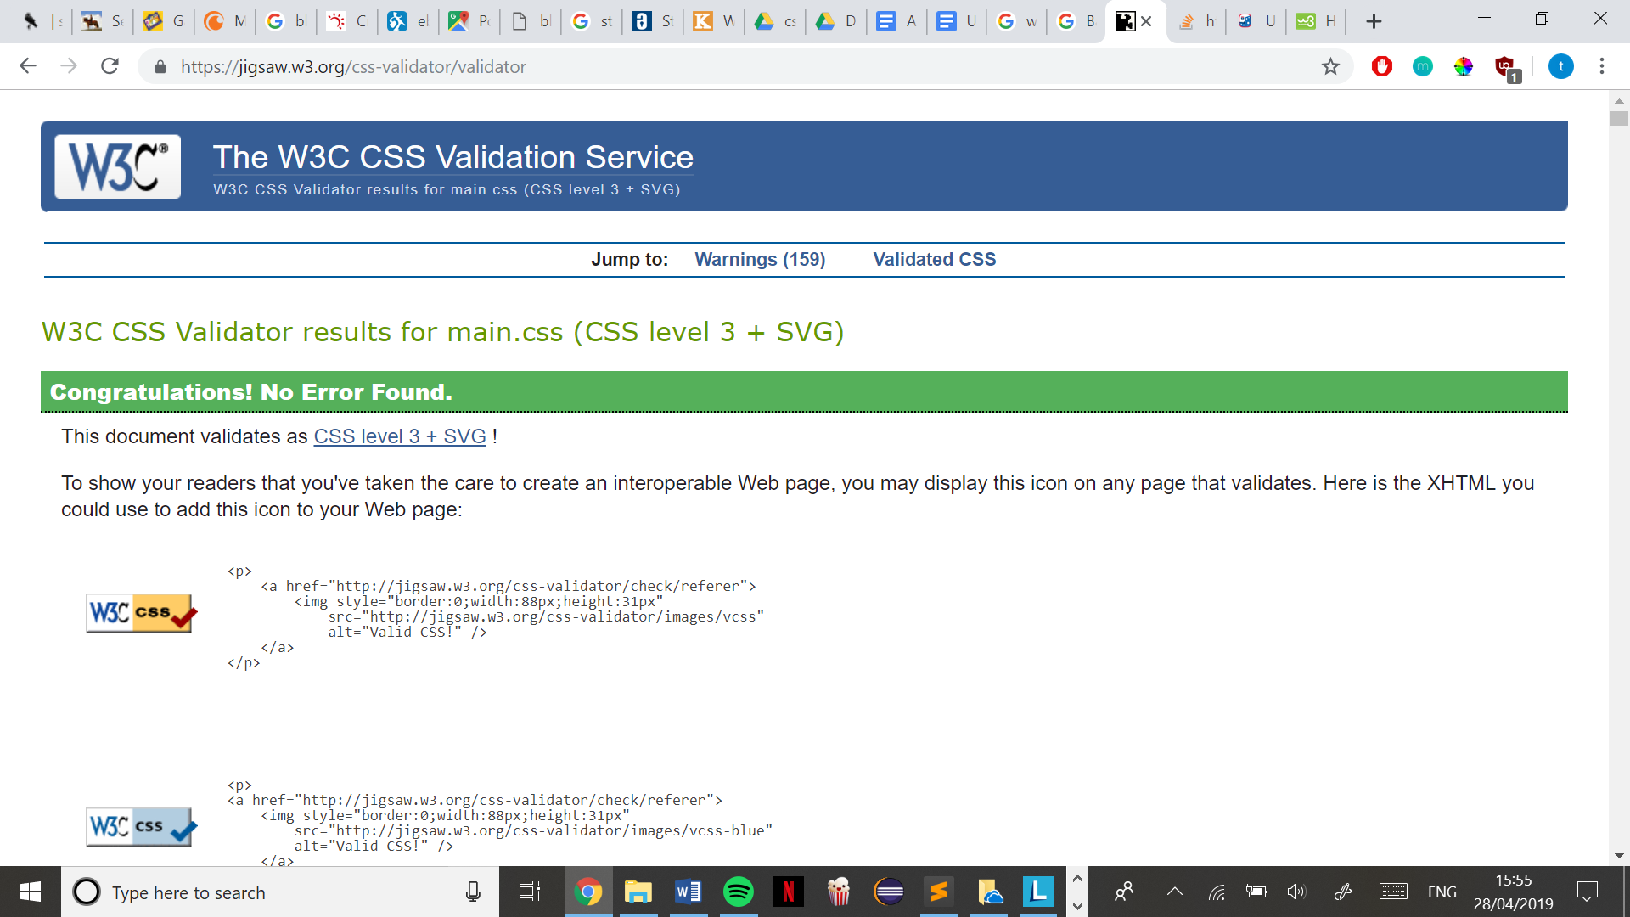

Vendor.css successfully passed, no errors found.

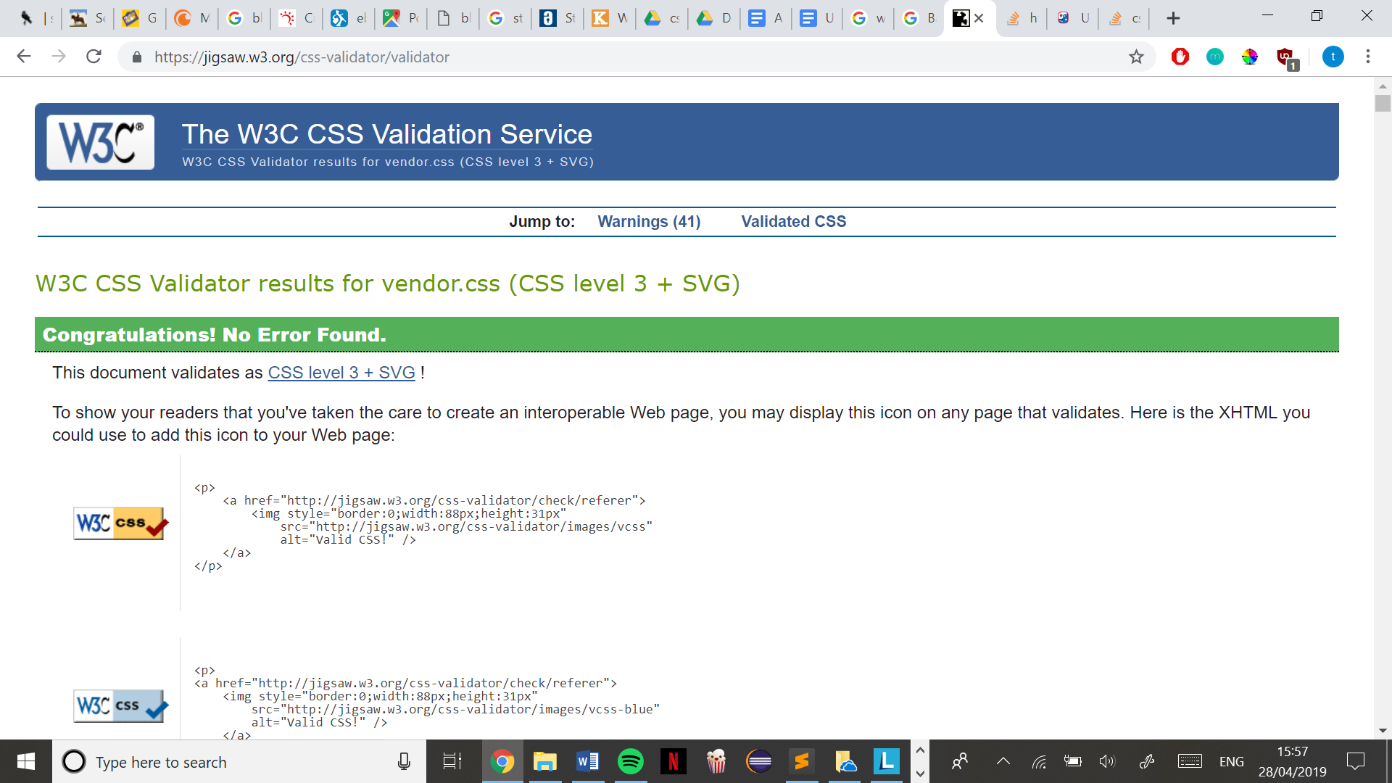

The website uses a free bootstrap layout ‘Kairos’ by StyleShout, downloaded from ThemeWagon